

**MSSQL Central Backup**

**Administration Guide**

1 Introduction 4

1.1 Objectives of the Centralized MSSQL Backup Solution 4

1.2 Tools 4

1.3 Security requirements 5

1.3.1 Service Account and Privileges 5

1.3.2 Network flows 5

1.3.3 Other requirements 5

2 Software Components 6

2.1 DBATOOLS 6

2.2 LOGGING 6

2.3 ROBOCOPY 6

2.4 One MSSQL Instance (2019+) 6

3 Scripts 7

3.1 Backups Scripts 7

3.1.1 BackupDatabasesOneInstance.ps1 script 7

3.1.2 BackupDatabasesFromCMS.ps1 script 13

3.2 Backups centralization to a central directory 15

3.2.1 RobocopyFromCMS.ps1 15

3.3 Purge scripts 17

3.3.1 PurgeFilesFromCMS.ps1 17

4 SQL Jobs and scheduling 19

4.1 Credential and Proxy SQL 19

4.2 Scheduling 20

4.3 Jobs 20

4.3.1 Job MSSQLBackupSolution-CMS-Backup-Full-ALL 20

5 Trace and Monitoring Databasebase 23

6 Update the solution 24

# Introduction

## Objectives of the Centralized MSSQL Backup Solution

The aim is to have a centralized and unique backup solution to manage backups of various databases located on MSSQL instances from a central instance, using SQL Server's CMS (Central Management Servers), which defines the list of instances to be backed up.

Adding or removing a target instance in the CMS allows for integrating or withdrawing this instance (and all its databases) into the centralized backup process without having to deploy anything on the target instance.

## Tools

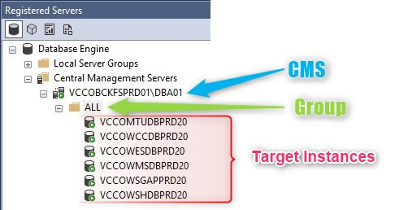To do this, PowerShell scripts with the DBATOOLS library are used.

The CMS, "Central Management Servers" in English, is a registry of SQL Server instances where instances of a company or a site are classified and recorded.

* From the central instance, backup scripts will be executed for each instance in the CMS embedded in the "ALL" group. Backups will be done locally on each target instance.
* 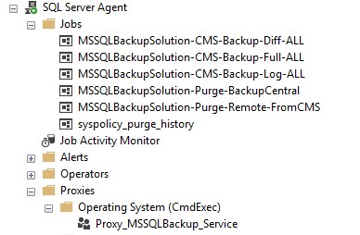Subsequently, a "robocopy" of the local backup files from each instance to the "Bastion" server will be carried out to centralize the backup files.
* Then, purge scripts will be launched to delete too old backup files.
* To schedule all the steps (backup, robocopy, purge), SQL jobs on the CMS instances are used to launch the PowerShell scripts.
* The results of the steps are recorded in a tracking table.
* The details of the steps are traced both in log files and in the history of the SQL jobs..

## Security requirements

### Service Account and Privileges

In order to perform backup operations on the target instances, robocopy the backup files between the targets and the central server, and to connect to the instance hosting the CMS and trace the backup results in a trace table, it is necessary to have:

* **A service account on the AD that will have the necessary rights**.
* Placing this service account in the BUILTIN\Administrators group of each target machine as well as on the central CMS server simplifies the installation.

### Network flows

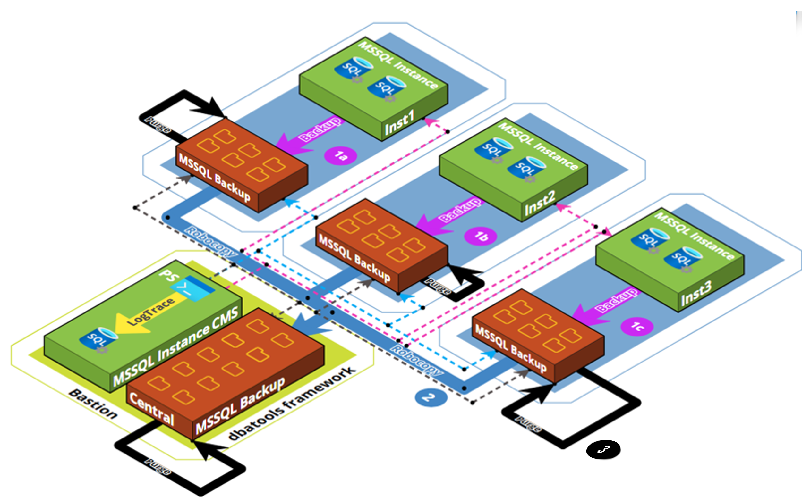

To enable the various Backup, Robocopy, and Purge actions, different TCP ports must be opened between the central server and the servers hosting the target MSSQL instances.

|  |  |  |
| --- | --- | --- |
| **Step** | **TCP Ports** | **Comment** |
| Backup (1) | 1433 | MSSQL Target Instances Port |
| Robocopy (2) | 445 (139) | SMB Port |
| Purge (3) | 445 (139) | SMB Port |

### Other requirements

In order not to mix up backups that would be carried out through different means (maintenance plans, local backup jobs, other central systems), **it is imperative to maintain only one classic backup mechanism for the databases** (full + differential + log).

# Software Components

The solution uses several software components:

* The PowerShell dbatools framework
* The PowerShell logging framework
* The Robocopy utility
* An MSSQL instance for database execution traces and to host the CMS

## DBATOOLS

**DBATOOLS** is a PowerShell library created by members of the SQL Server community, including individuals working directly at Microsoft on SQL Server. This library is intended for database administrators to manage various issues through command line scripts. It has very good documentation and is very intuitive, which allows for the creation of scripts that can be quickly understood by another DBA or system administrators.

The website dbatools.io compiles the documentation of the commands of this framework with numerous examples: <https://dbatools.io/commands/>

The installation of this component is done during the installation of the MSSQLBACKUP solution.

This component is used to:

* List the databases to be backed up
* Perform the backups
* Push the results into the trace table.

## LOGGING

**LOGGING is a PowerShell library** that allows for properly tracing the execution of scripts in log files.

## ROBOCOPY

**ROBOCOPY is a Windows utility** that allows for robust file transfers. It will be used to retrieve backup files generated on each target instance to a central directory on the machine managing the backups.

## One MSSQL Instance (2019+)

**An SQL Server instance is used to house the CMS and the SQL jobs responsible for scheduling backups.**

**A trace database is used to centralize the results of the backup executions,** thus providing a single source that allows the state of the completed backups to be restored and problems to be detected.

**Note: An edition with the Job Agent component is necessary.**

# Scripts

There are various scripts necessary for the solution. By default, the scripts are located in **D:\MSSQLBackupSolution**, and the logs are in the Logs subdirectory.

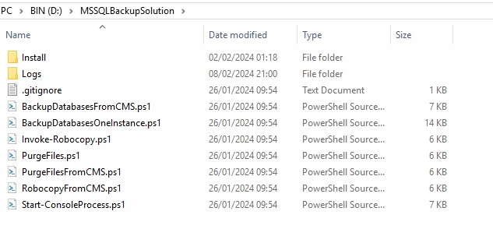

## Backups Scripts

There are two scripts involved in the backup process:

* **BackupDatabasesOneInstance.ps1**, which allows for backing up all the databases of a single instance.
* **BackupDatabasesFromCMS.ps1**, which enables calling the previous script for all instances of a group passed as a parameter.

### BackupDatabasesOneInstance.ps1 script

**BackupDatabasesOneInstance.ps1** is designed to back up all the databases of an instance. This script takes the following parameters

#### Parameters

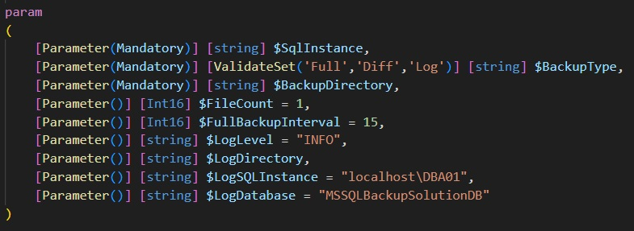

* **SqlInstance:** The target instance that one wishes to back up.
* **BackupType:** The type of backup one wants to perform: Full, Differential (Diff), or Log.
* **BackupDirectory:** The directory on the target instance where the backup files will be stored.
* **FileCount:** The number of backup files for a database that one wishes to have in order to distribute the data and gain performance. By default, a single file is generated per backup**.**
  + - **FullBackupInterval:** The number of days difference with the last full backup that is tolerated. If this condition is not met, a full backup is performed. This only applies when performing a Differential (Diff) or Log backup, as these types of backups rely on the last full backup. Therefore, if the last full backup is non-existent or too old, a new full backup is initiated.
    - **LogLevel:** The log levels of the scripts are currently set directly in the scripts with an INFO level.
    - **LogDirectory:** The directory where the script's log files will be stored to check if the script execution went well. Monitoring the proper execution is very important, hence the need to implement logging to quickly diagnose a problem.
    - **LogInstance:** The instance where the results of the script execution will be recorded.
    - **LogDatabase:** The database on which the successful execution of the script will be recorded in tables. This allows, in addition to log files, another trace of what happened. Storing script execution information in tables enables further analysis, such as creating dashboards.

#### Example of a manual launch

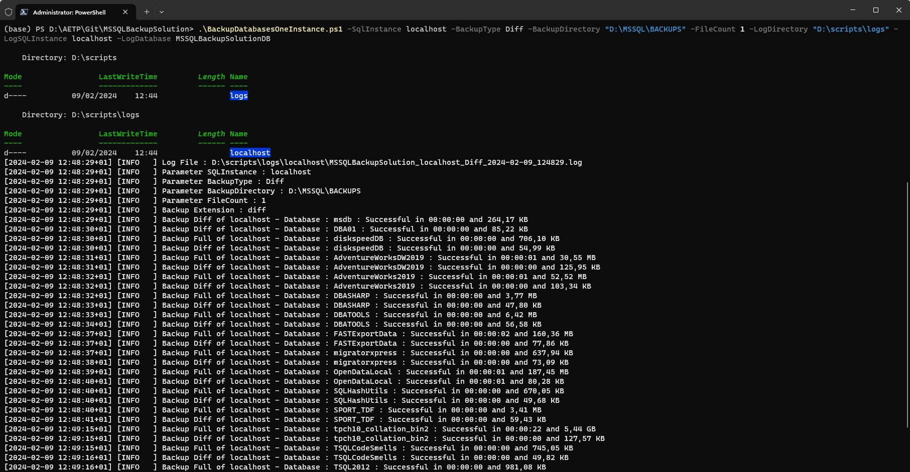

#### Code details

In the section of the code below, for each type of backup, the extension of the backup file to be used is determined. Additionally, an inventory of the databases to be backed up is conducted by verifying that their "RecoveryModel" status is set to Full or Bulk Logged, indicating that the logs of the respective database need to be backed up, unlike databases in Simple recovery mode. Finally, certain system databases (like tempdb, model) are excluded.

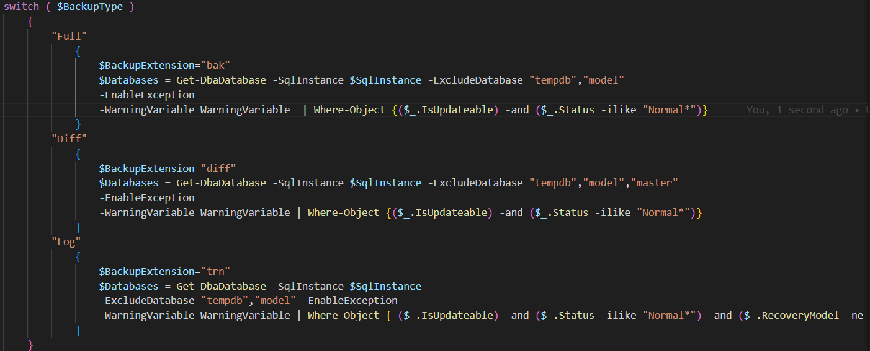

Subsequently, a Foreach loop is executed to back up each database present in the list. This process includes a check for Differential or Log backups to ensure that a Full backup exists or is more recent than the number of days specified by the **FullBackupInterval** parameter.

The backup for each database is executed using the DBATOOLS command line as follows:



**It's important to note the presence of the switches -CheckSum and -Verify**, which allow for respectively ensuring that the written data blocks are consistent (-CheckSum) and that the backup file is readable and valid upon re-reading (-Verify).

The parameter "-OutVariable" is used to retrieve an array containing all the backup execution information for the particular database into a variable, "BackupResults" in our case. The next step is to insert this array into a log table to have a record of the Backup results on SQL Server.



#### Database Traces :

Then, the table can be queried in SSMS (SQL Server Management Studio) to obtain more detailed information about the backup process.

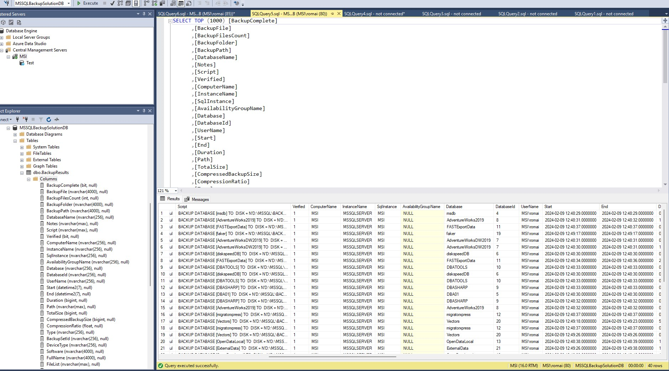

#### Log file :

Below, we will see what a log file for a backup of an instance looks like. Using Visual Studio Code, we can clearly see that everything has gone well with the green color code, and in red if an error has occurred. Additionally, we can clearly see the different parameters with which the script was executed. Then, for each database, we can observe the time needed to perform the backup and the size of the generated file.

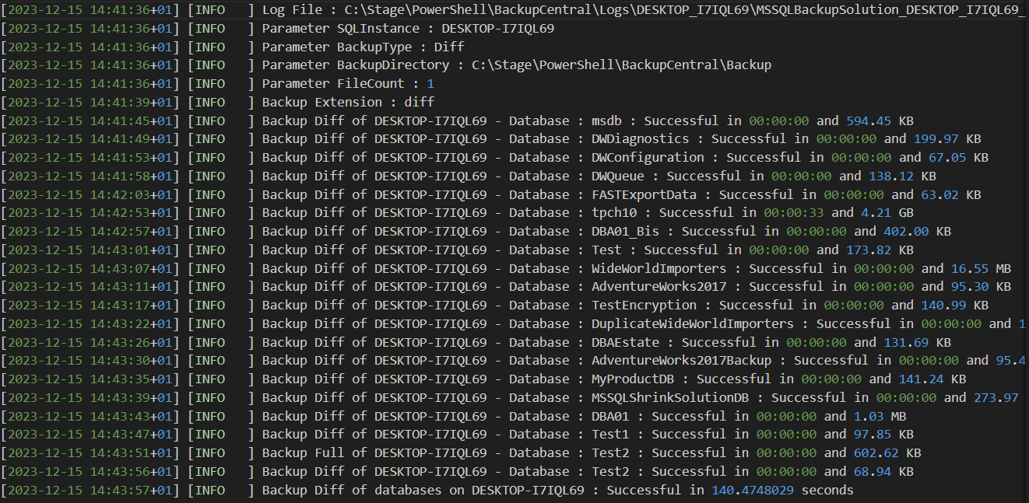

#### Backup Files Hierarchy

For each instance, we get standardized folders for each of the databases that have been backed up. There is a fixed common root followed by a hierarchy that adheres to the following standard:

**G:\BACKUPDB\**

**<**SERVERNAME>\

<INSTANCENAME>\

<DATABASENAME>\

<BACKUPTYPE>\

<DATABASENAME>\Files

Note: If the instance is not named, <INSTANCENAME> takes the value "MSSQLSERVER".

On the centralized CMS server, the hierarchies are also found in the same way but on a different root:

**G:\MSSQLBackupsCentral\**

**<**SERVERNAME>\

<INSTANCENAME>\

<DATABASENAME>\

<BACKUPTYPE>\

<DATABASENAME>\Files

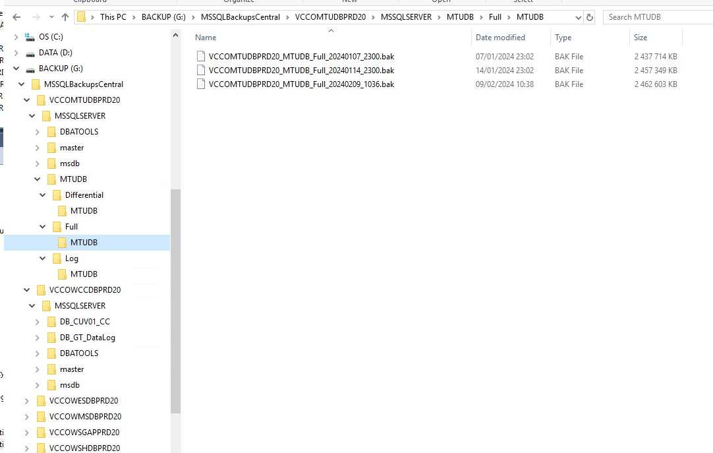

#### backups files naming

<INSTANCENAME>_<DATABASENAME>_<BACKUPTYPE>_<YYYYMMDD>_<HHMI>.<Suffix>

Suffix :

* Full 🡺 .bak
* Differential 🡺 .diff
* Logs 🡺 .trn

Example :

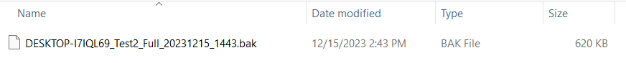

### BackupDatabasesFromCMS.ps1 script

**BackupDatabasesFromCMS.ps1** retrieves all the instances from the CMS group that one wishes to back up and executes the **BackupDatabasesOneInstance.ps1** backup script for each of them, propagating the other parameters (BackupType, BackupDirectory, etc.).

**Note: It is this script that will be launched in the SQL jobs.**

#### Parameters

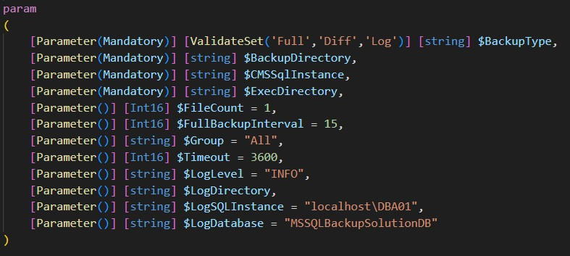

* **CMSSqlInstance :** The instance hosting the CMS.
* **Group**: The name of the root group in the CMS that will be used to list the instances to be backed up. The traversal is recursive. Instances in other sub-groups will also be accounted for.
* **BackupType**: The type of backup to perform: Full, Differential (Diff), or Log.
* **BackupDirectory**: The directory on the target instance where the backup files will be stored.
* **FileCount**: The number of backup files for a database desired in order to distribute the data and enhance performance. By default, a single file is generated per backup.
* **FullBackupInterval**: The number of days' difference from the last full backup that is tolerated. If this condition is not met, a full backup is performed. This only applies when performing a Differential or Log backup, as these backups rely on the last full backup. Therefore, if the last full backup is non-existent or too old, a new full backup is initiated.
* **LogDirectory**: The directory where the script's log files will be stored to verify if the script execution went well.
* **LogInstance**: The instance where the script execution will be recorded. In our case, the instance will be the "Bastion".
* **LogDatabase**: The database in which the successful execution of the script will be recorded in tables. This allows for an additional trace of what happened, besides the log files.
* **LogLevel**: The log levels of the scripts are currently set directly in the scripts with an INFO level.

#### Code details

Retrieving Instances from the CMS:

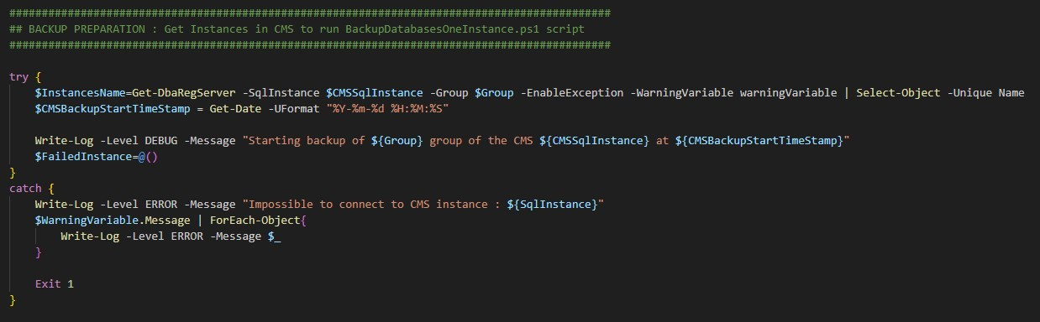

Execution of the BackupDatabasesOneInstance.ps1 script for each retrieved instance with the propagation of parameters (BackupType, FileCount, LogDirectory, LogInstance, etc.):

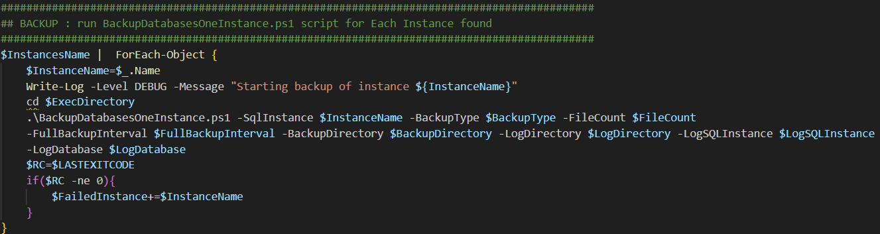

## Backups centralization to a central directory

What needs to be well understood is that we control, from the central bastion, the execution of backup scripts; however, the backup files created are only present on the servers of the target instances.

Once the backup scripts are completed, it is necessary to retrieve the backup files present on each instance to the central server. For this purpose, we use PowerShell scripts and modules that will invoke the **robocopy** utility and remap error codes for better error management.

### RobocopyFromCMS.ps1

The script **RobocopyFromCMS**.ps1 also searches in the CMS for all instances for which we want to centralize the backup files. Then, for each instance, we copy the backup files to the Bastion using an **Invoke-Robocopy command, which allows potential errors to be reported back to the caller.**

Note : This script is called in the MSSQL jobs.

#### Parameters

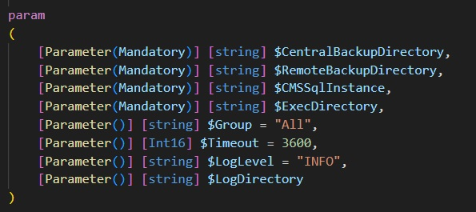

• **CentralBackupDirectory**: The directory where all backup files will be centralized.

• **RemoteBackupDirectory**: The root directory where backup files are located on the remote instance.

• **CMSSqlInstance**: The instance hosting the CMS.

• **ExecDirectory**: The directory where the script is located.

• **Group**: The name of the CMS group where we want to copy the backup files.

• **Timeout**: Timeout for robocopy.

• **LogDirectory**: The directory where log files will be stored to track the script's execution.

• **LogLevel**: The log levels for the scripts are currently defined within the scripts themselves with an INFO level.

#### Code details

Retrieving instances with backup files to be copied.

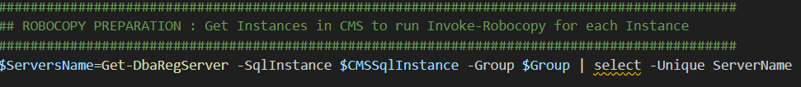

The difficulty with **Robocopy** lies in **remapping** **error codes**.

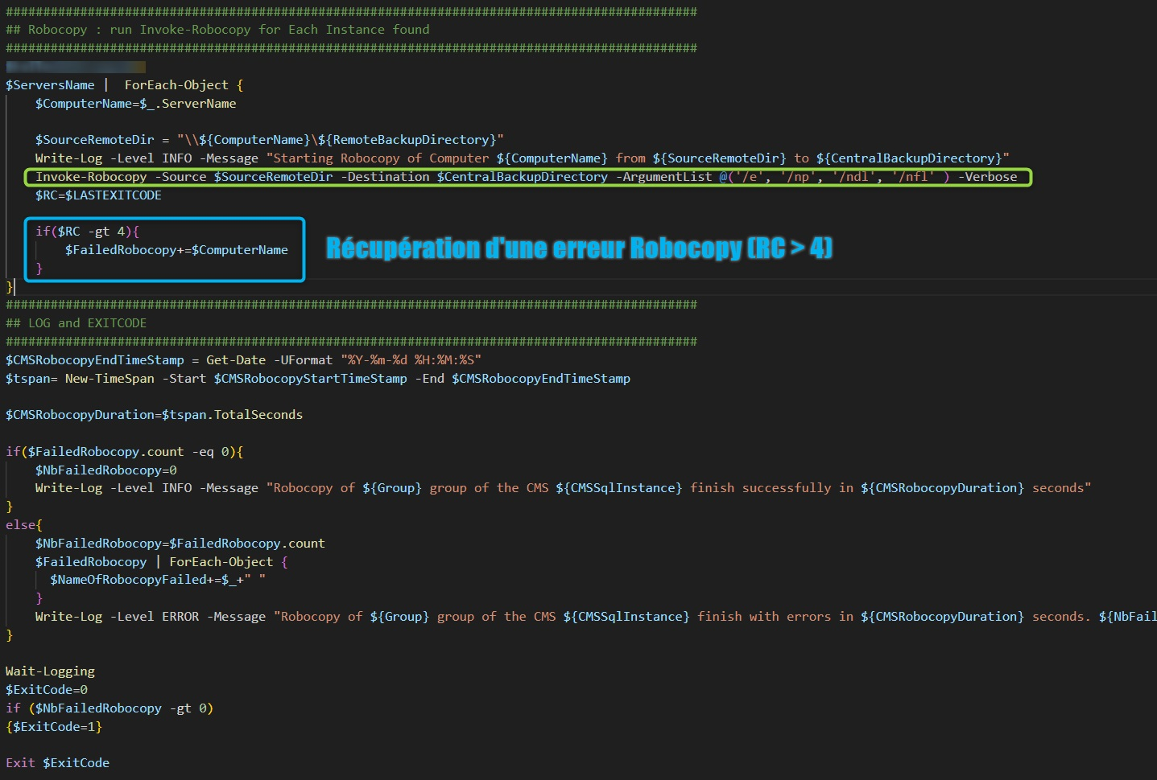

This way, we can report actual errors from Robocopy rather than warnings or successful copies that return an exit code of 1 instead of 0.

## Purge scripts

In a third step, once the backup of the instances is completed and the files are copied to the "Bastion," it is necessary to purge old backup files and log files to prevent the storage space of each local instance and the central instance from being saturated.

If desired, we can determine different **retention periods** based on the type of backup (full, differential, or log). For example, keeping Full backups for 30 days, Differential backups for 2 weeks, and log backups for 1 week.

For this purpose, we use "PurgeFilesFromCMS.ps1," which purges files of a specific extension for an instance with an appropriate value for the retention period parameter: $HoursDelay.

### PurgeFilesFromCMS.ps1

Note : This script is called in the MSSQL jobs.

#### Parameters

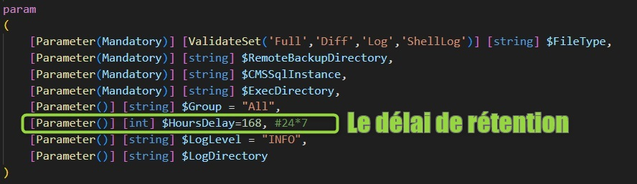

• **FileType**: The type of file that we want to purge, either Full, Diff, Log for backup files or ShellLog for log files generated by PowerShell scripts.

• **RemoteBackupDirectory**: The directory containing the backup or log files. This directory will be used to construct a UNC path with the name of the target machine. For example, "G$\BACKUPDB".

• **CMSSqlInstance**: The instance hosting the CMS.

• **Group**: The name of the CMS group that we want to purge.

• **HoursDelay**: Retention period for backups in hours.

• **LogLevel**: Log level (default is INFO).

• **LogDirectory**: The directory where log files will be stored to track the execution of the script.

#### Code details

We retrieve all instances belonging to the CMS group passed as a parameter and store them in the variable **$ServersName**

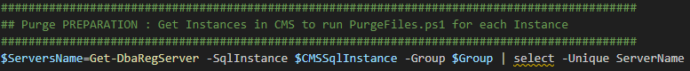

The variable **$SourceRemoteDir** is utilized to construct and reference the remote directory of each instance containing the files to be purged by concatenating the machine name with the **$RemoteBackupDirectory** parameter. Subsequently, the script "PurgeFiles.ps1" is executed with the correct parameters.

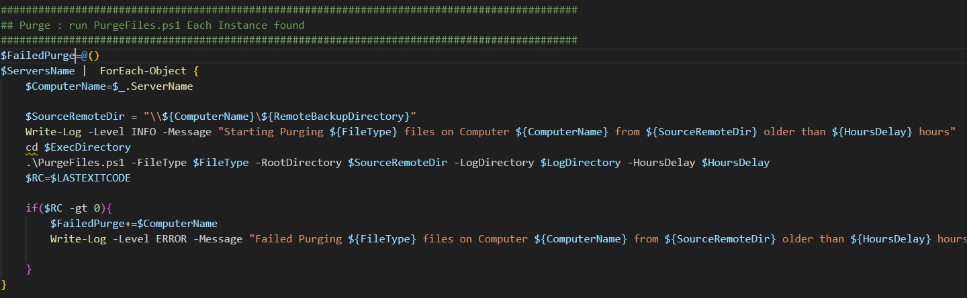

#### Execution trace files

The trace files for purges are prefixed by Purge_

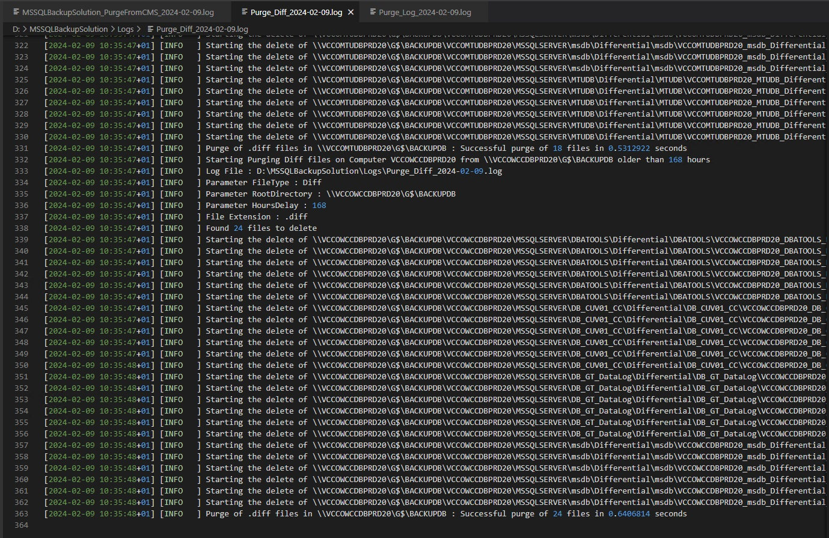

# SQL Jobs and scheduling

The solution is deployed with several jobs allowing scheduling of FULL, DIFF, and LOG backups as well as purges on both remote servers and the central server.

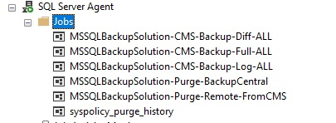

To achieve a longer retention period for SQL Agent logs, it is recommended to increase the Agent history depth.

To do so, execute the following SQL command with a sysadmin user:

|  |
| --- |
| EXEC msdb.dbo.sp_set_sqlagent_properties @jobhistory_max_rows=999999, @jobhistory_max_rows_per_job=10000  GO |

## Credential and Proxy SQL

Each job consists of steps, and each step is responsible for executing a PowerShell script. To ensure that error reporting is properly handled, the steps should be of type CmdExec, and a Proxy must be defined. The proxy relies on a credential (a credential object within the central MSSQL instance). This credential, named ServiceAccount4MSSQLBackups, is created during installation, but it can be modified if necessary.

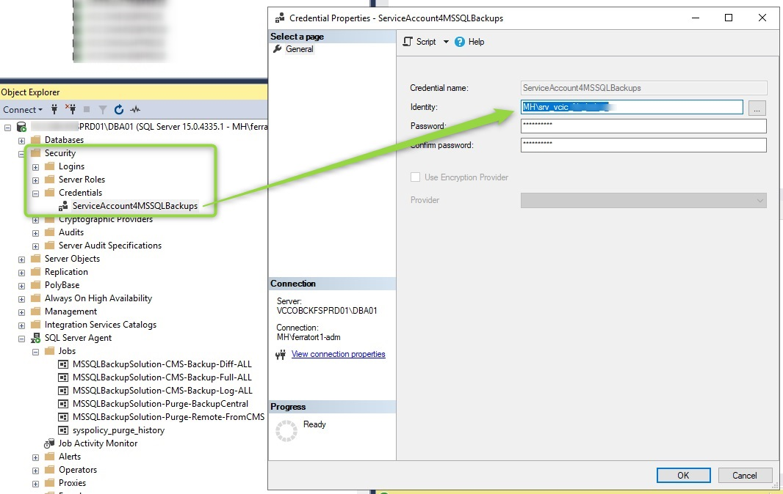

## Scheduling

Default schedules are created during the installation process.

|  |  |  |
| --- | --- | --- |
| Job | Frequency | Scheduling |
| Backup Full | Weekly | Dimanche 23h |
| Backup Diff | Daily | Daily 23h (except sunday) |
| Backup Log | Hourly | Every 30 minutes |
| Purge remote target | Daily | Daily 21h |
| Purge Central | Daily | Daily 22h |

Note: Since the solution is centralized and sequential, backups will occur as needed, and the startup times on remote servers will not be identical between different launches. This approach has the advantage of limiting the impact on central disks by avoiding a significant peak in load if all servers were to perform their backups exactly at the same time.

## Jobs

### Job MSSQLBackupSolution-CMS-Backup-Full-ALL

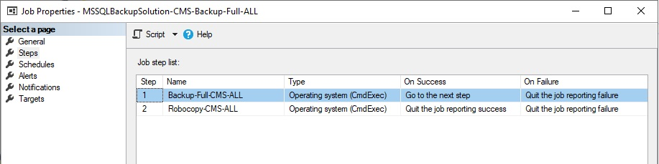

The backup full job (like diff and log) consist of 2 steps: the actual backup part and then the Robocopy part which triggers immediately afterward.

#### Backup Step

This step calls the script D:\MSSQLBackupSolution\BackupDatabasesFromCMS.ps1 with the parameter BackupType = Full.

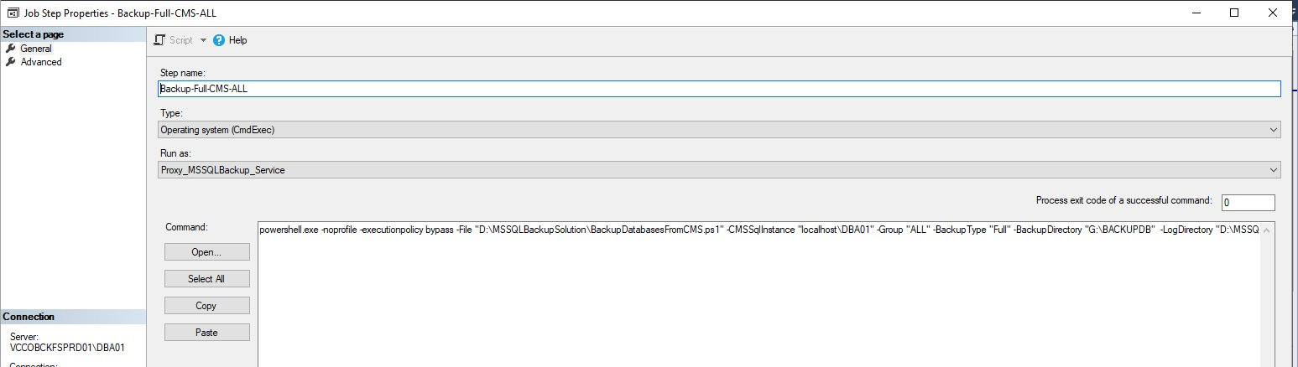

|  |
| --- |
| powershell.exe -noprofile -executionpolicy bypass -File **"D:\MSSQLBackupSolution\BackupDatabasesFromCMS.ps1"** -CMSSqlInstance "localhost\DBA01" -Group "ALL" -BackupType "**Full**" -BackupDirectory "G:\BACKUPDB" -LogDirectory "D:\MSSQLBackupSolution\Logs" -ExecDirectory "D:\MSSQLBackupSolution" |

#### Robocopy Step

The next step launches the script D:\MSSQLBackupSolution\RobocopyFromCMS.ps1, which retrieves all files that have not already been copied to the central location.

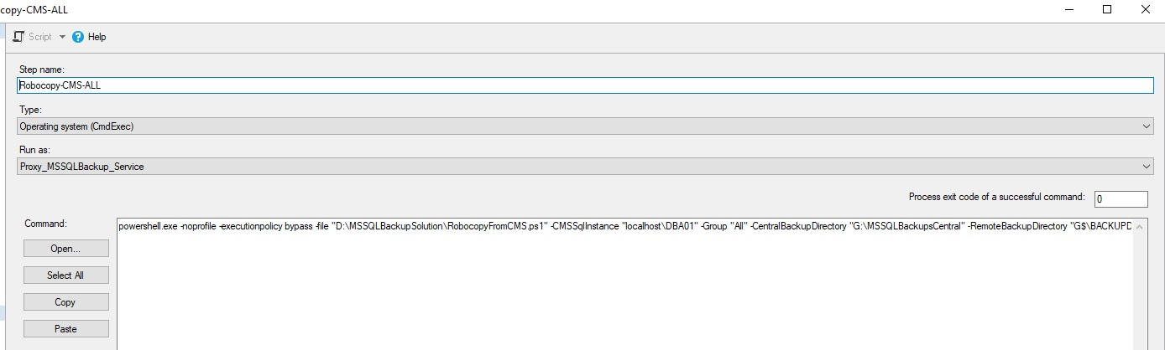

#### SQL Agent log history

Thanks to the capabilities of the SQL Agent, it is possible to monitor the logs of processes directly through the job history.

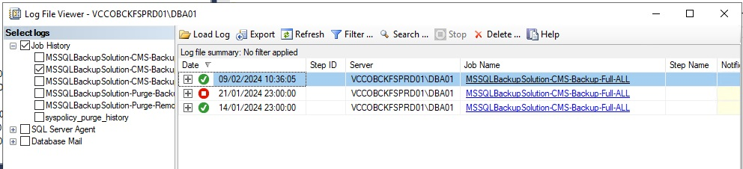

The detail of the steps provides more information:

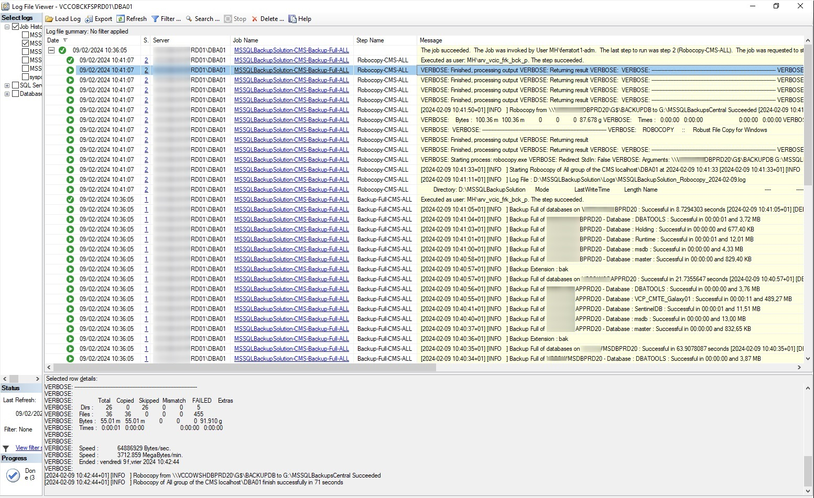

### Job MSSQLBackupSolution-CMS-Backup-Diff-ALL

### Job MSSQLBackupSolution-CMS-Backup-Log-ALL

# Trace and Monitoring Databasebase

The trace database is located on the instance installed on the central server. This database contains a table for tracking and reporting the success or failure of job steps: backup, robocopy, and purge. However, other issues may arise that could hinder the proper execution of backup processes.

To ensure that databases are adequately secured, it is necessary to implement backup monitoring. This monitoring can verify if the age of backups (full, differential, or log) aligns with the requirements by relying on data from the centralized backup trace table.

Another, even more reliable technique would be to use the CMS and dedicated scripts to list the latest valid backups by type (full, differential, log) for all databases from MSSQL system tables.

# Update the solution

Since the solution is based on a set of PowerShell scripts, updating can be done in two ways:

* + - If the platform is connected to the internet and security policy allows it, a git pull from the release branch can be performed to update the scripts.
    - If the platform is not connected to the internet or if security policy prohibits connection to github.com, the latest packaged release can be retrieved from GitHub (.zip) and the files can be unzipped into a temporary directory. It is advisable to backup the PowerShell scripts on the CMS platform before overwriting them with the scripts from the new version.